Paul Polsinelli

IFT 220 – 90917a

9/7/20

Lab 5

* + 1. Open Control Panel and select system and security.

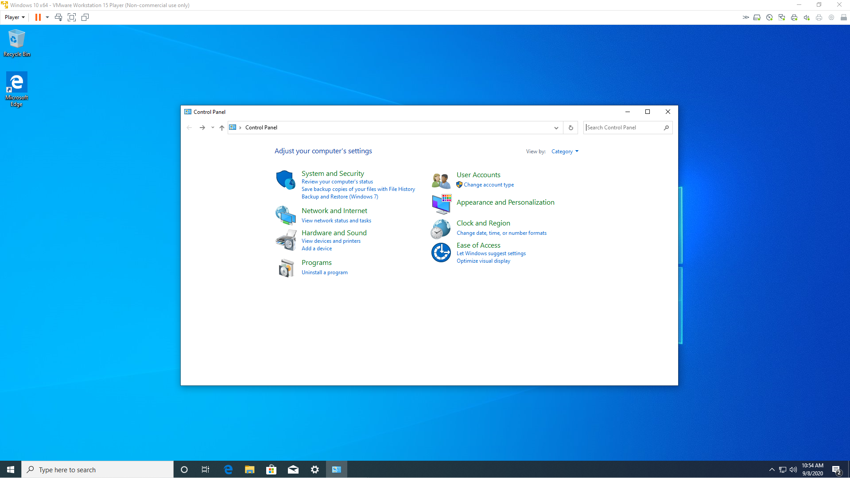

* + 1. Select System.

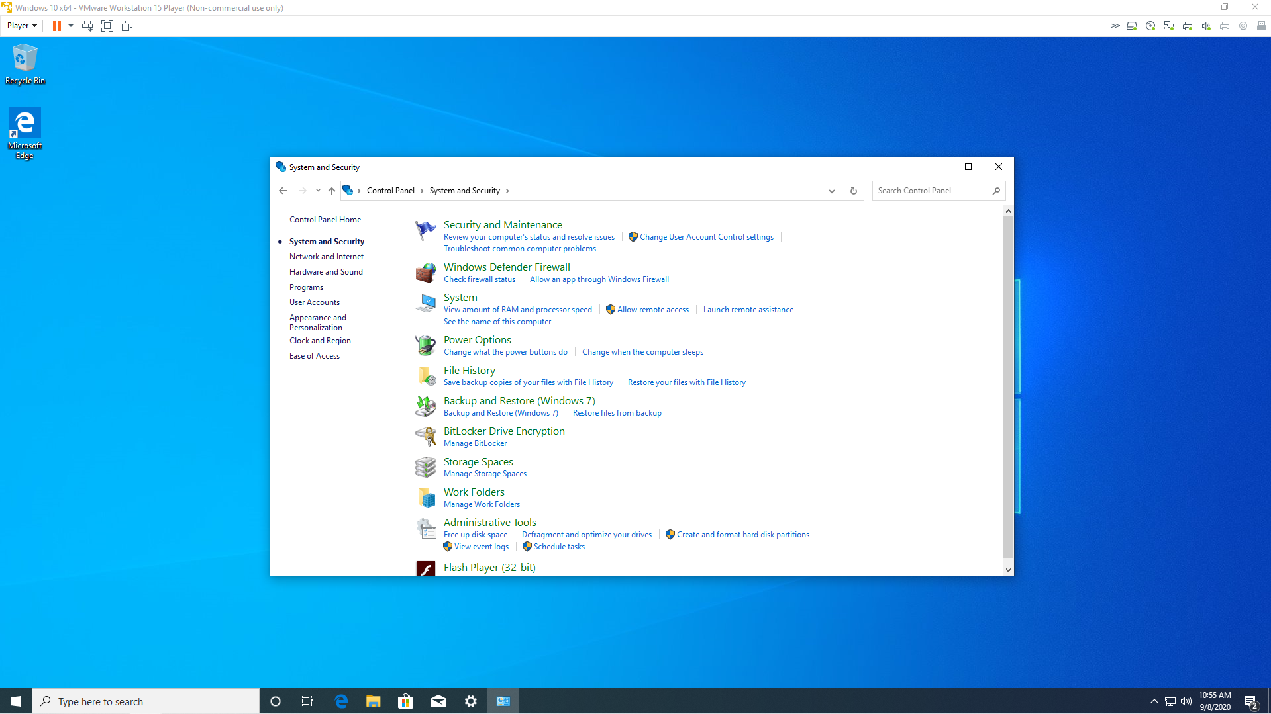

* + 1. Click Change settings under Computer name, domain, and workgroup settings.

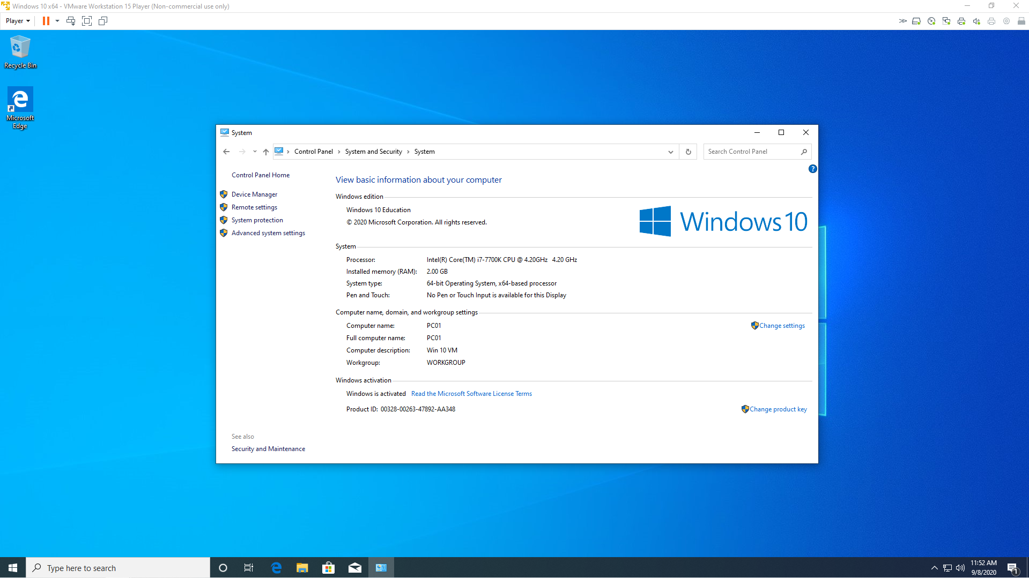

* + 1. Click Change in the System Properties box.

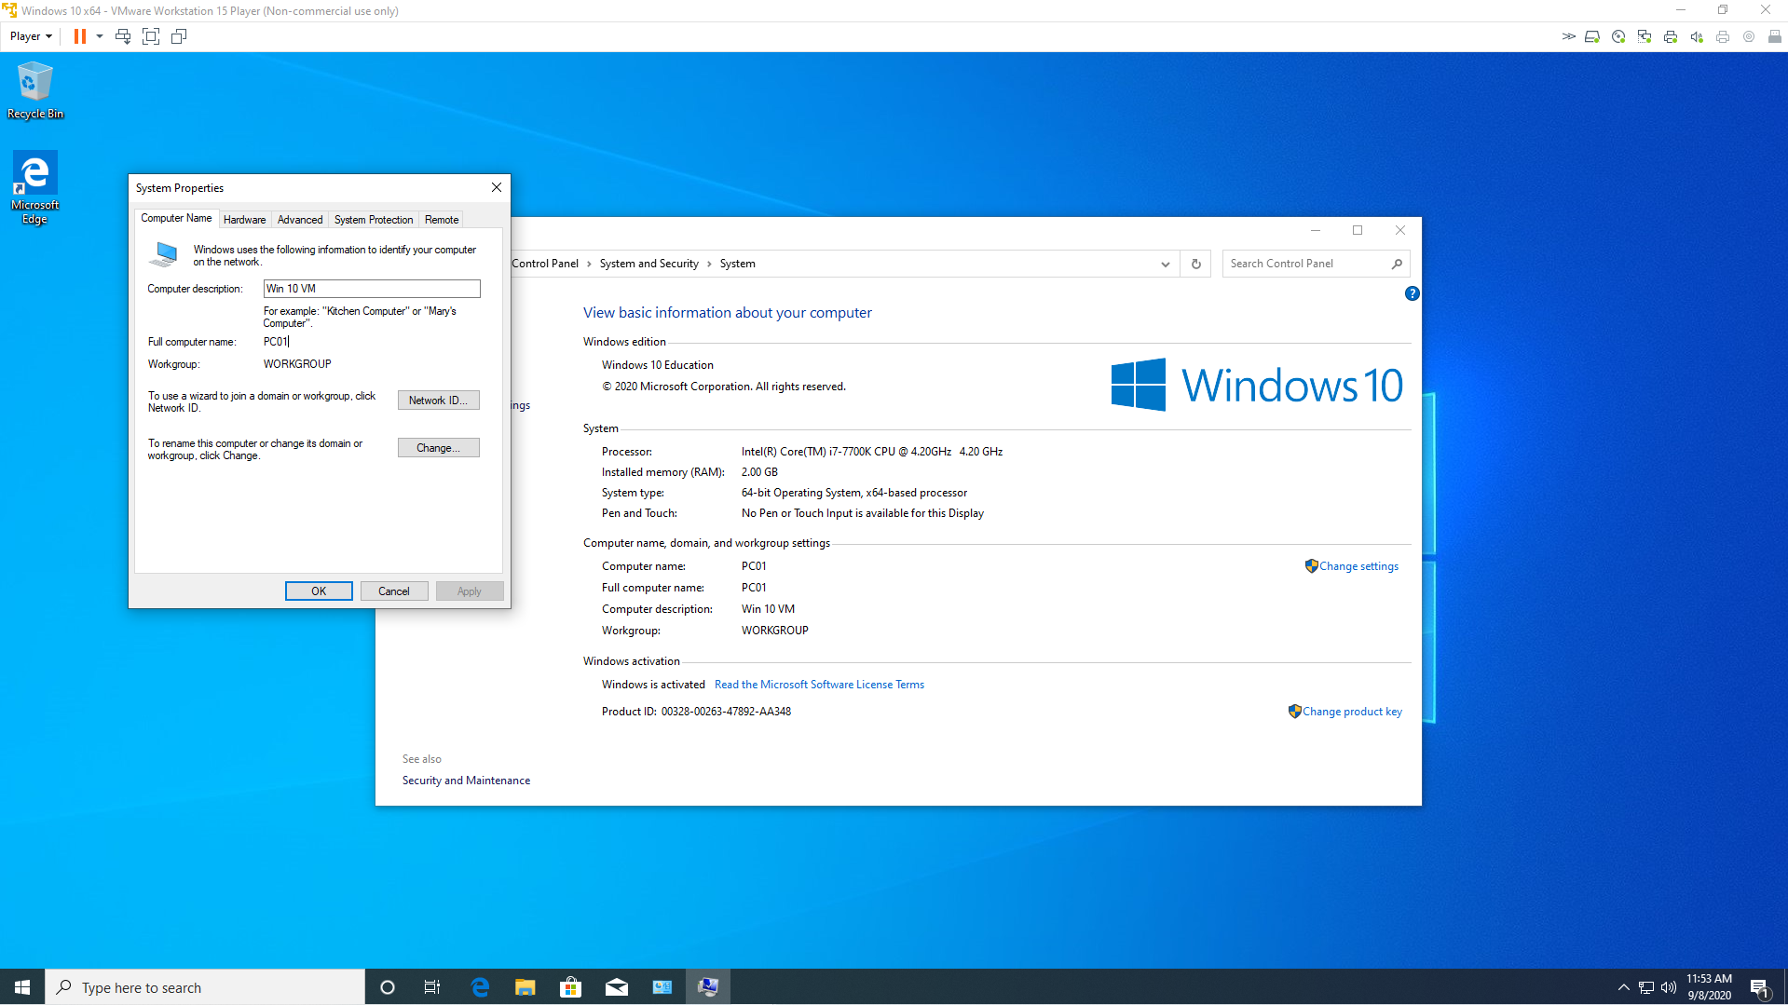

* + 1. Click the Domain radio button and enter the name of your domain. This is where I encountered trouble and it couldn’t find the domain. Ultimately, I changed the loopback address on my server to it’s own IP address and turned off Windows Firewall on both systems to fix the problem.

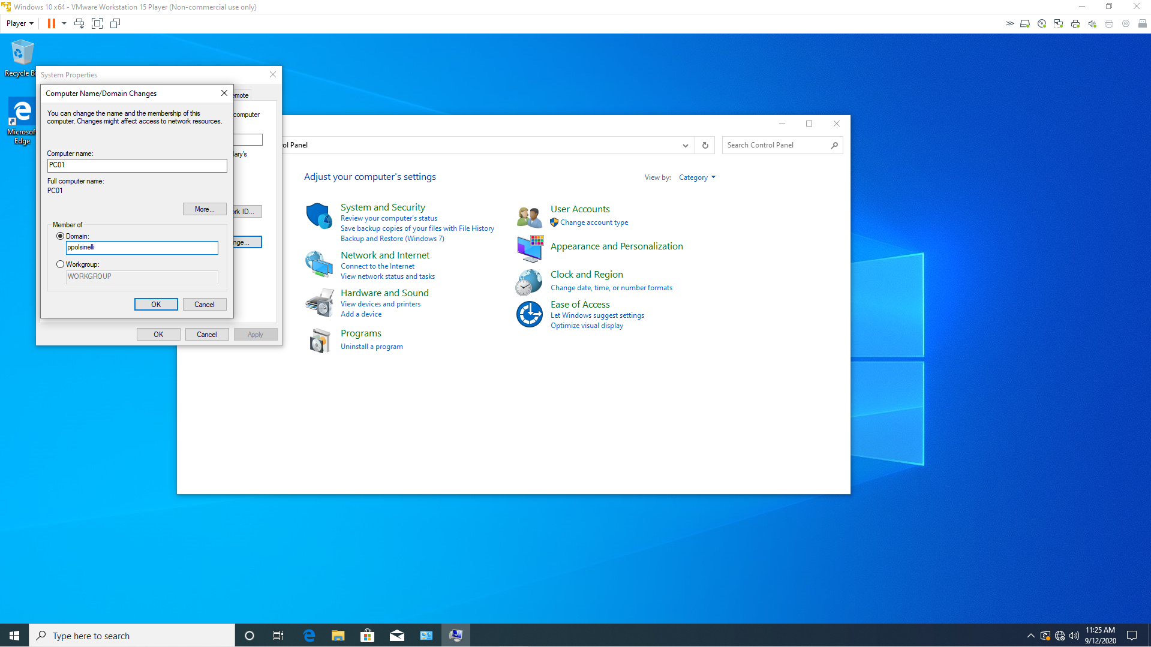

* + 1. Enter your computer name of your server and password. Click OK.

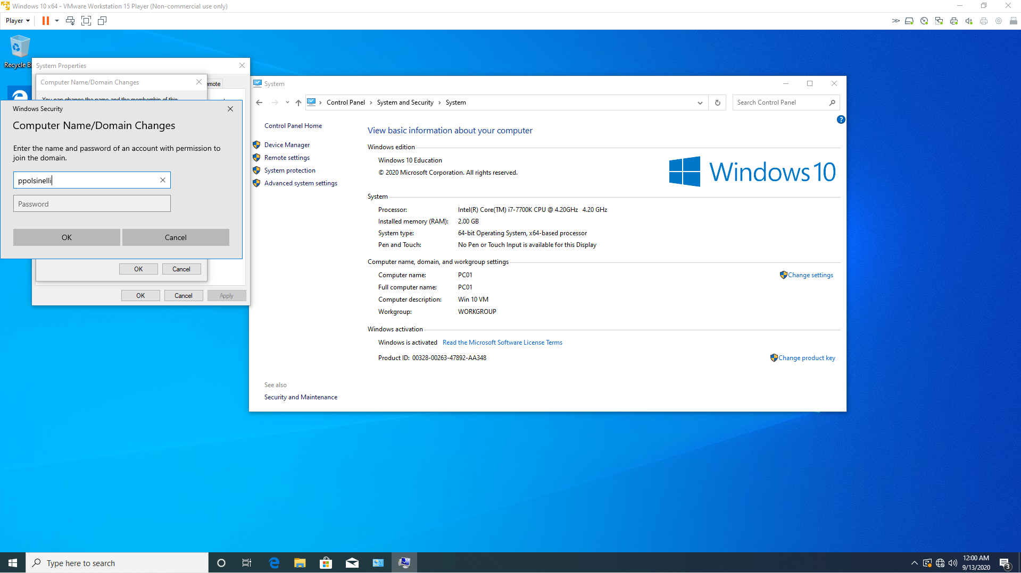

* + 1. Click OK.

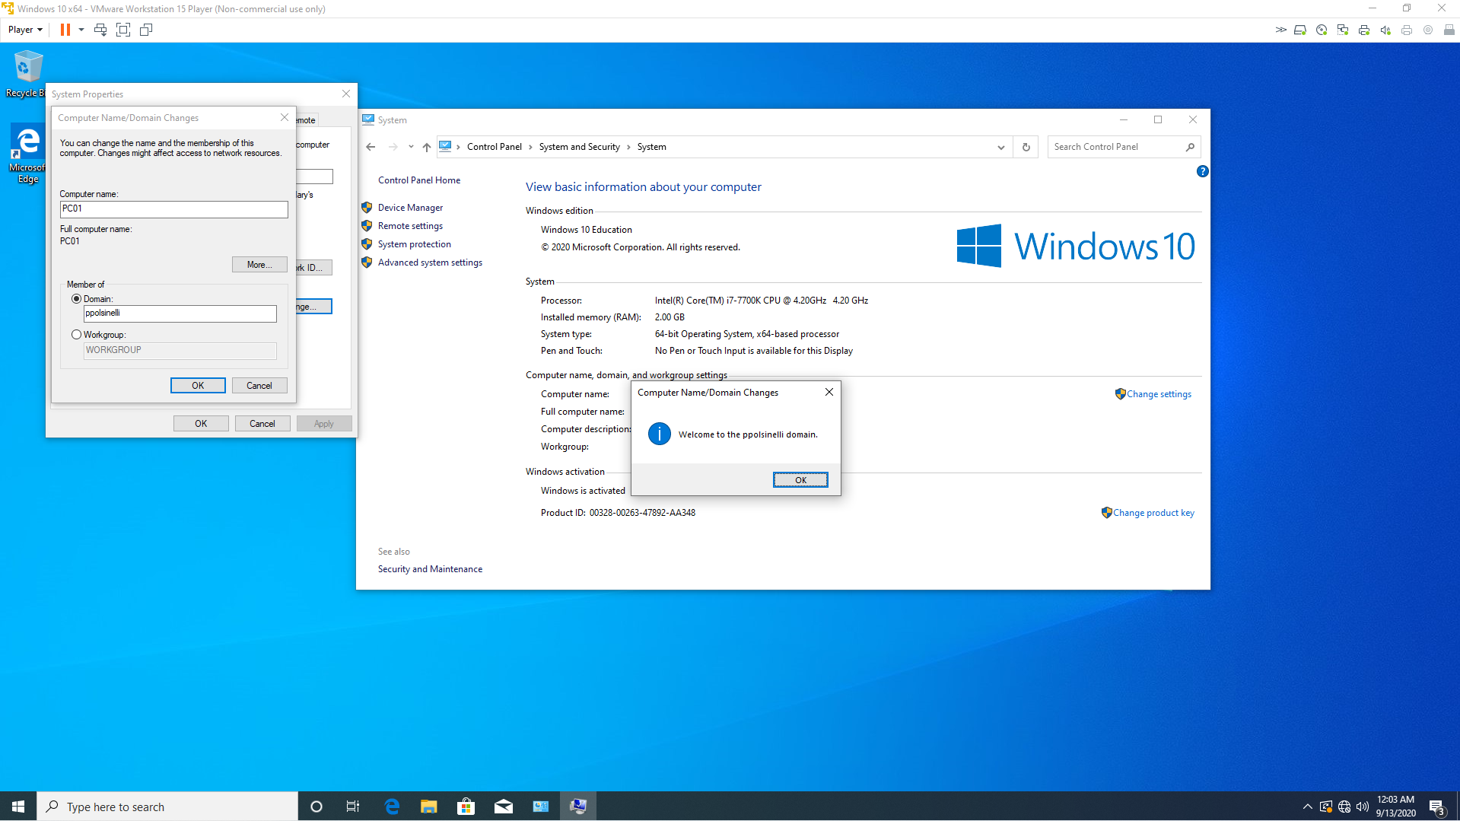

* + 1. Restart and you are joined.

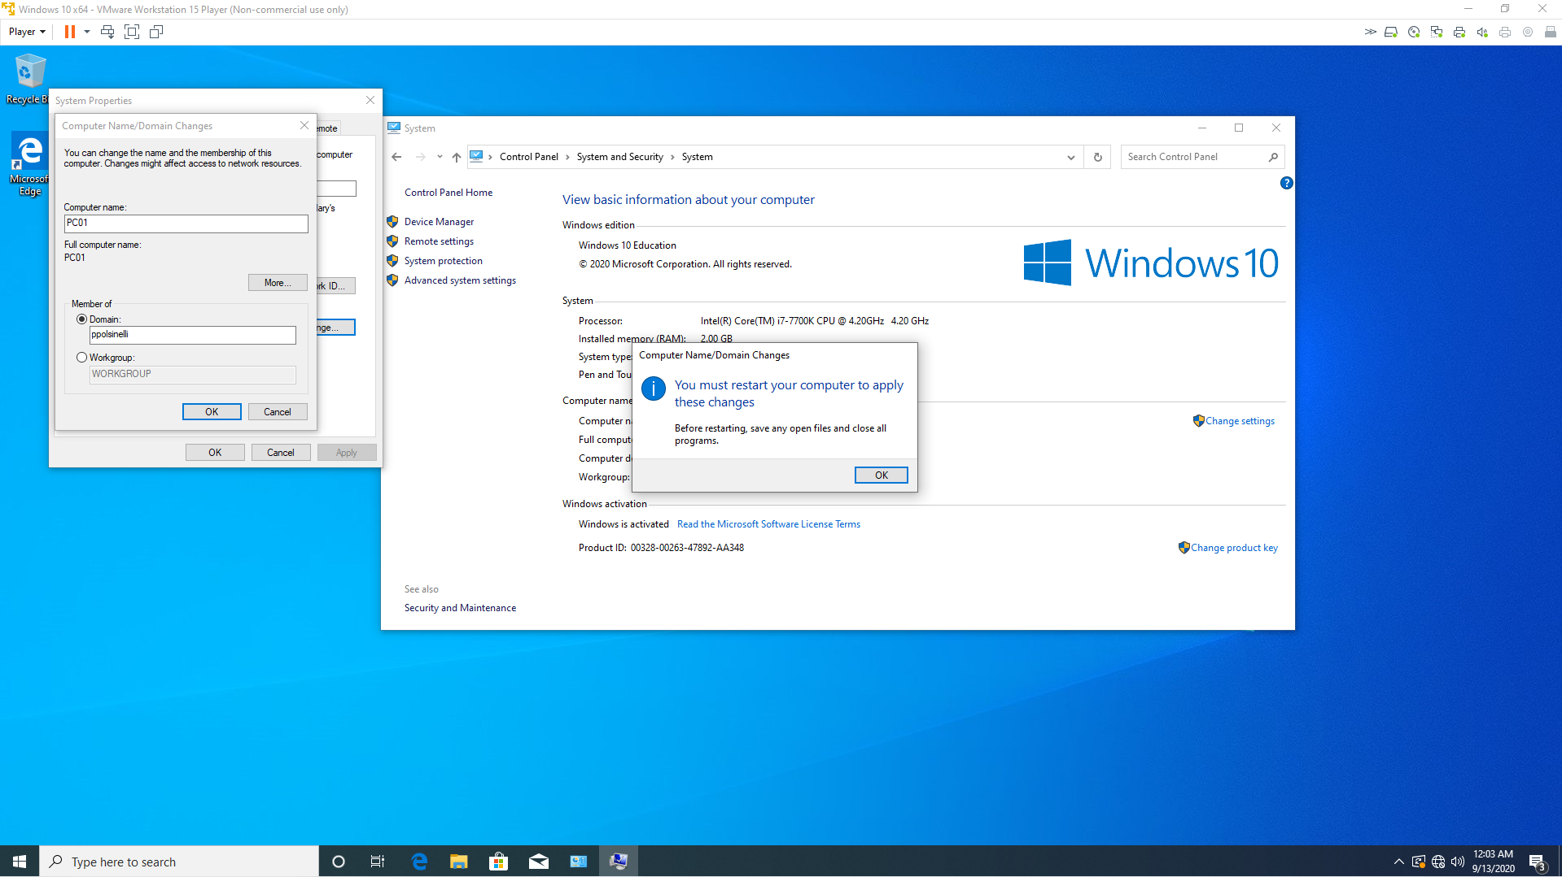

* + Running 'winver' from the Start Menu.

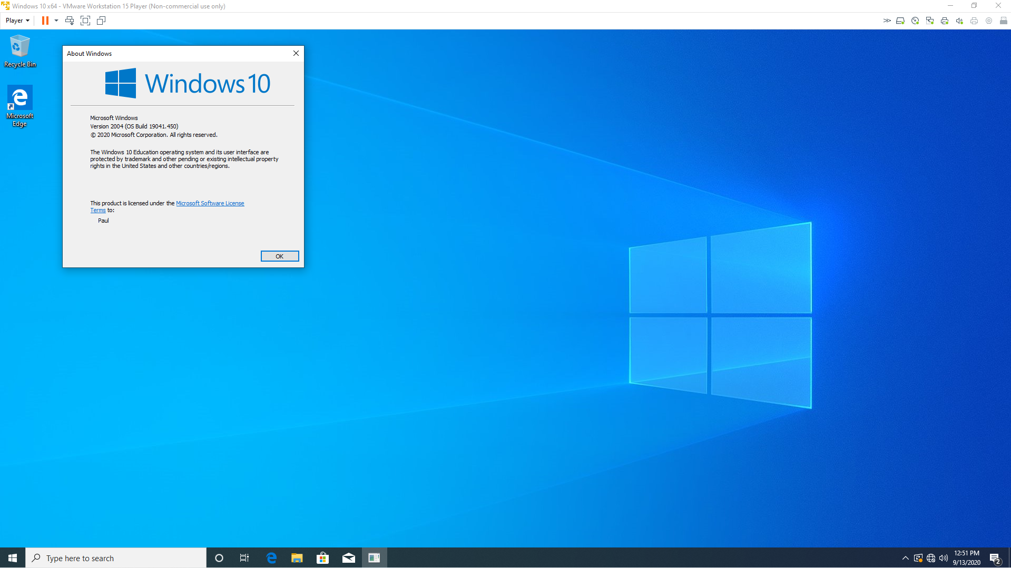

* + Running 'ipconfig /all' from PowerShell. 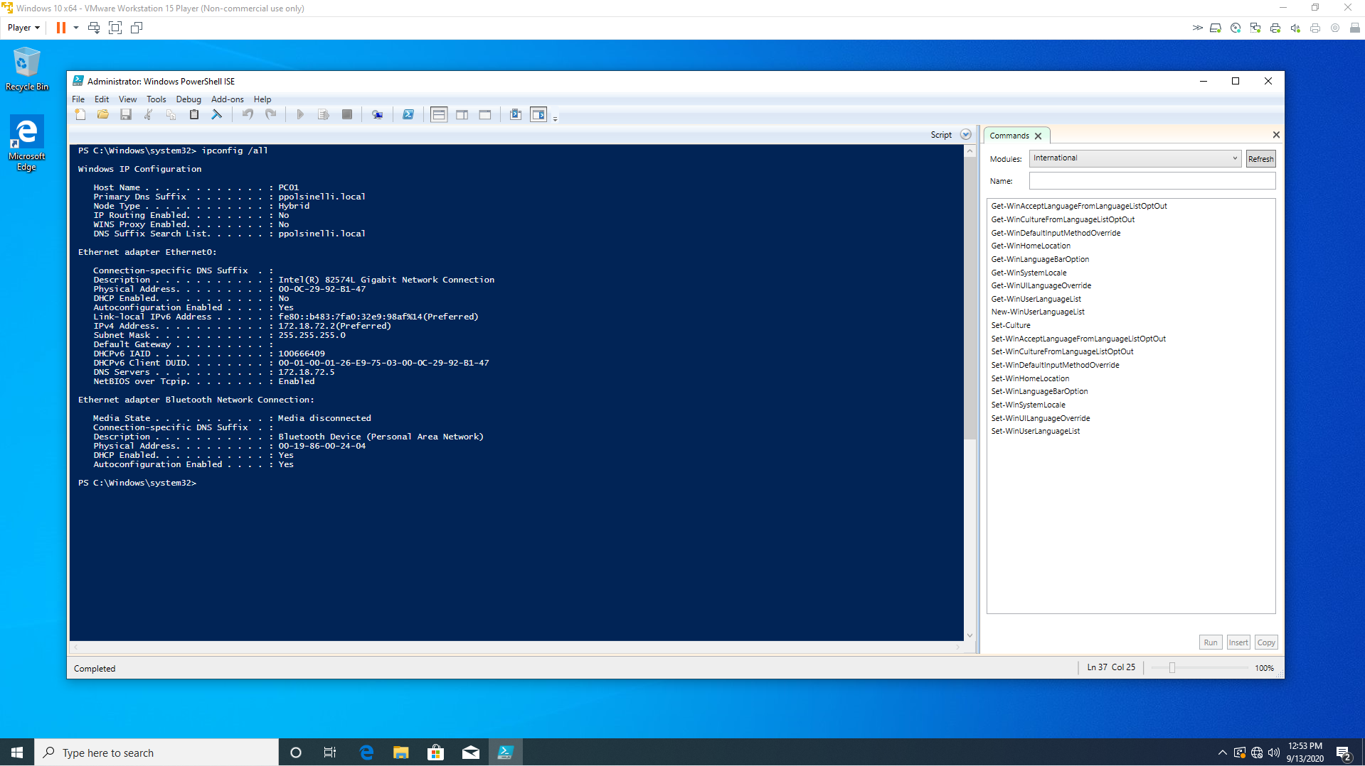

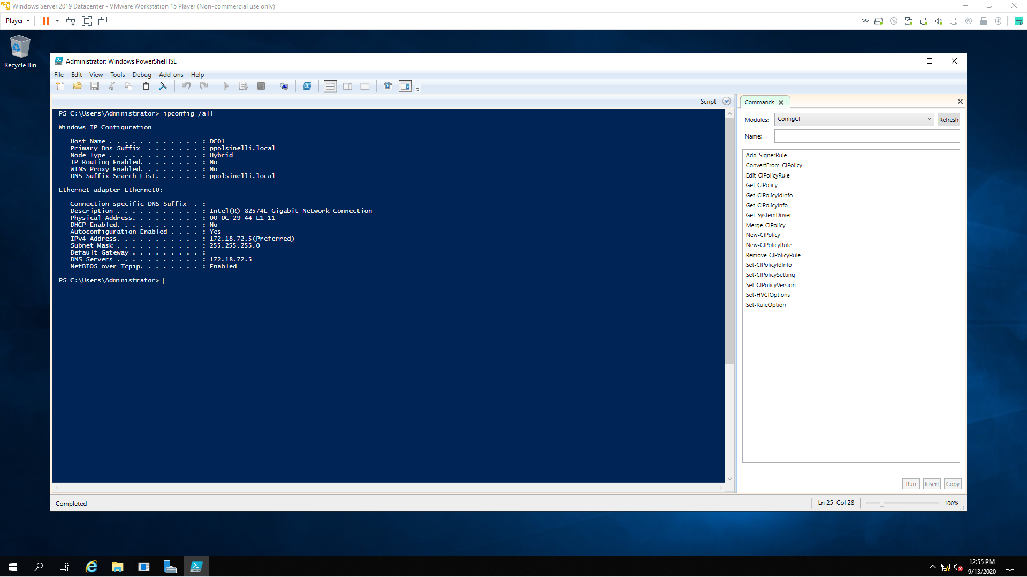

* + Screenshot showing the accounts of the Administrators group on your Windows 10 client system.

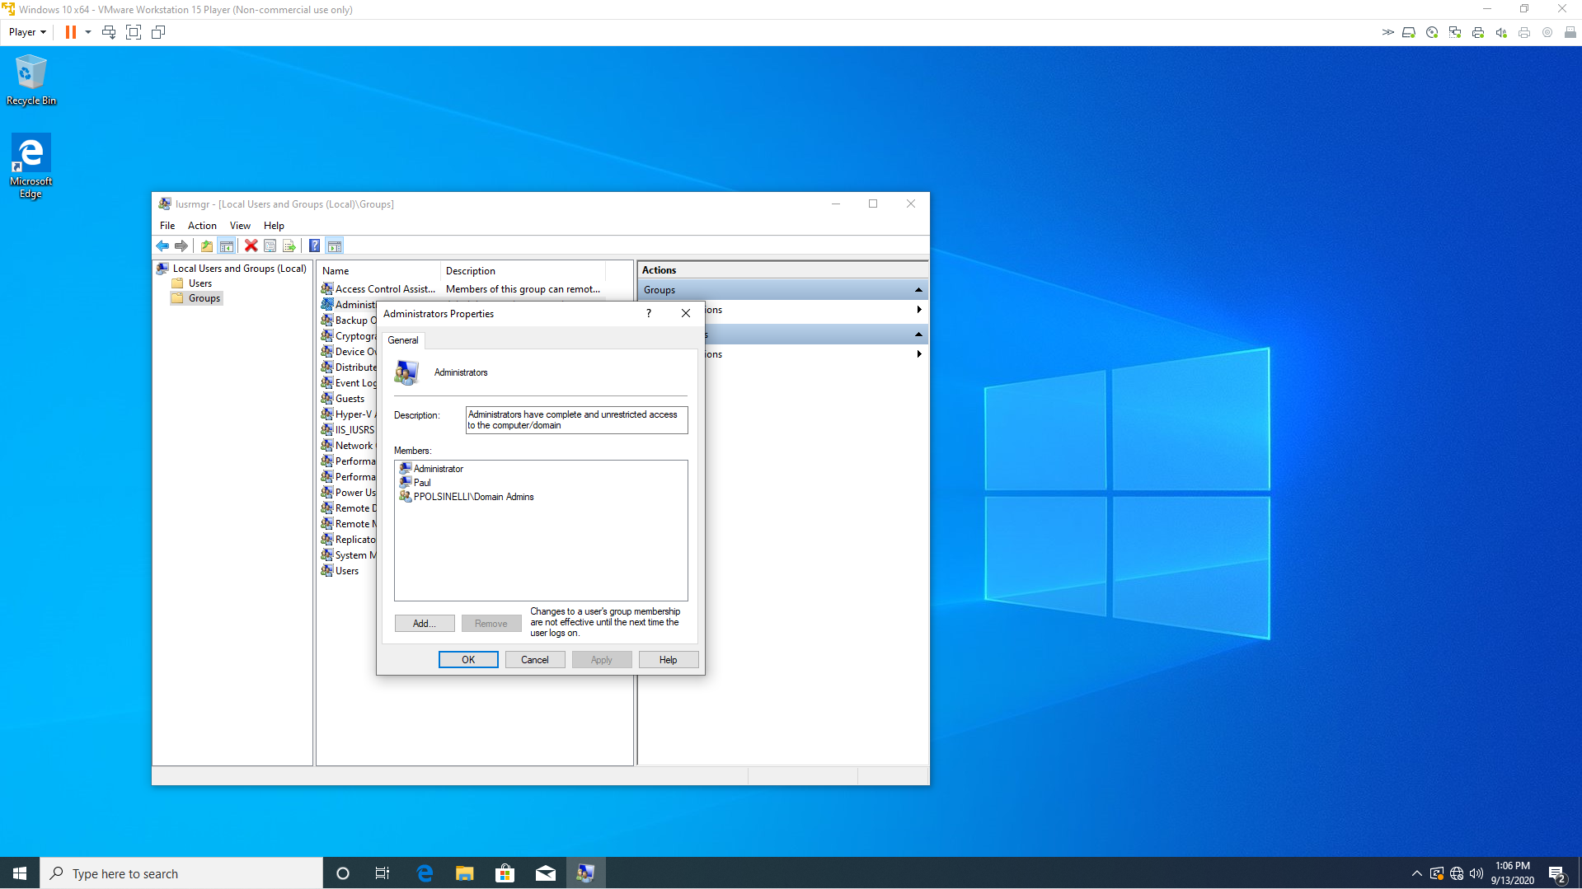

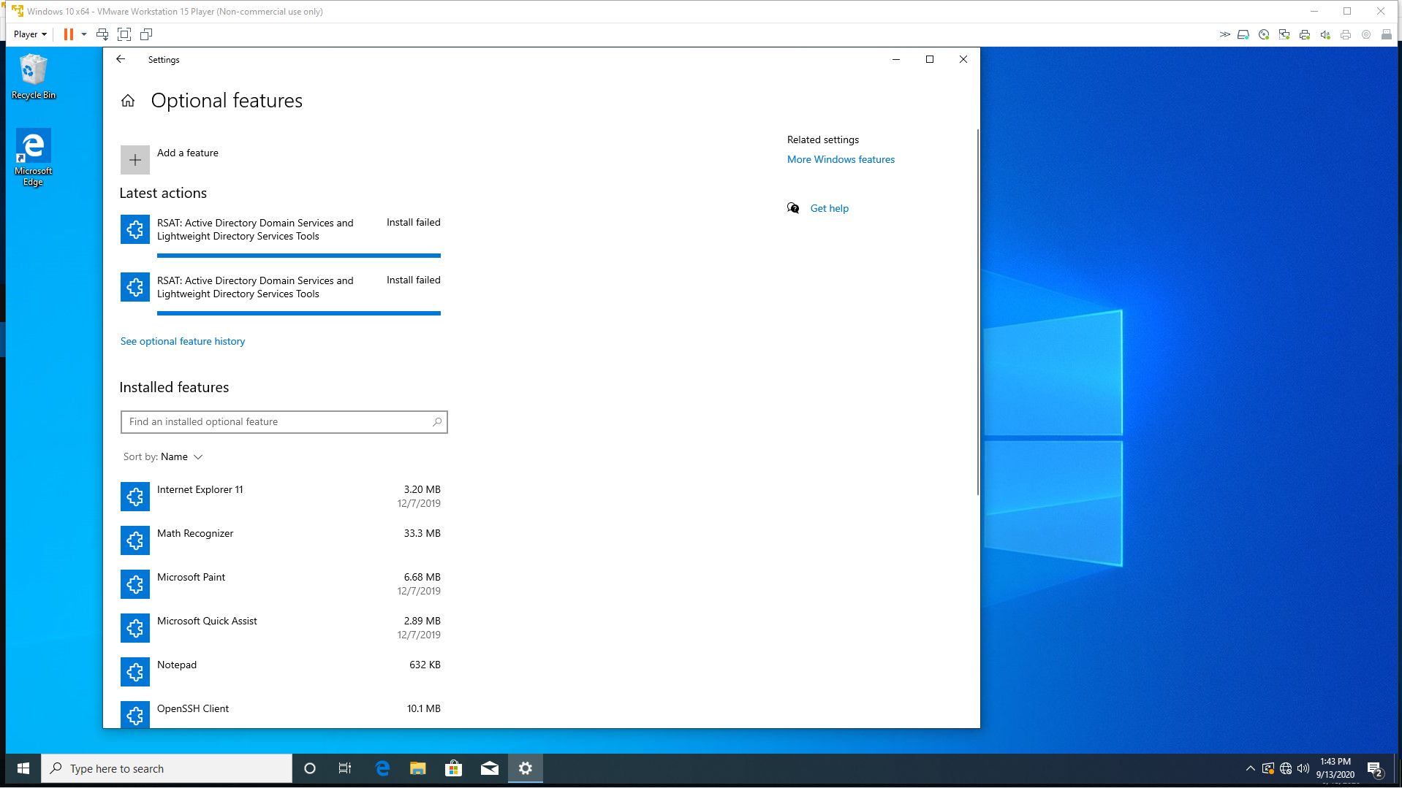

I used VMware Workstation 15 player for both DC01 and PC01. Win 10 ver 2004 and Windows Server 2019 Datacenter.